# Caching with REDIS

## What is Redis

Redis is an open source, in-memory data structure store, used as a database, cache and message broke. It supports data structures such as strings, hashes, lists, sets, sorted sets with range queries, bitmaps, hyperloglogs, geospatial indexes with radius queries and streams.

## How does it works

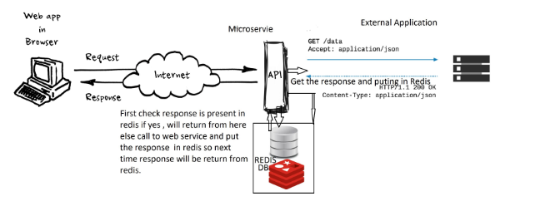

## Download and Install Redis-5.0.5

1. Download and Install redis-5.0.5 from: <https://redis.io/download>
2. Start the redis server : D:\Farkalit\softwares\redis-5.0.5\bin>redis-server

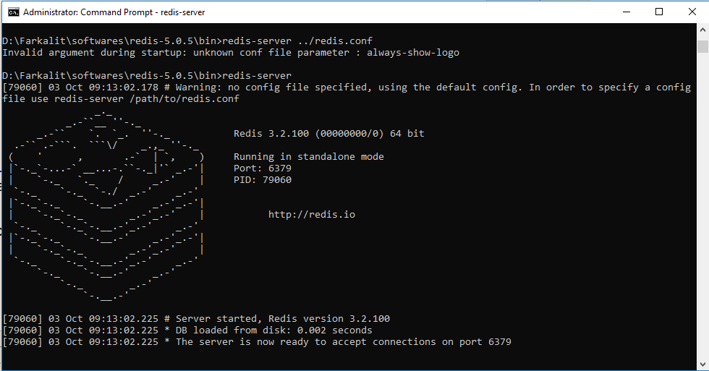

1. For your own configuration please set the values in file: $../redis-5.0.5/redis.conf
2. Start with conf file : D:\Farkalit\softwares\redis-5.0.5\bin>redis-server ../redis.conf
3. To test the server is working : D:\Farkalit\softwares\redis-5.0.5\bin>redis-cli

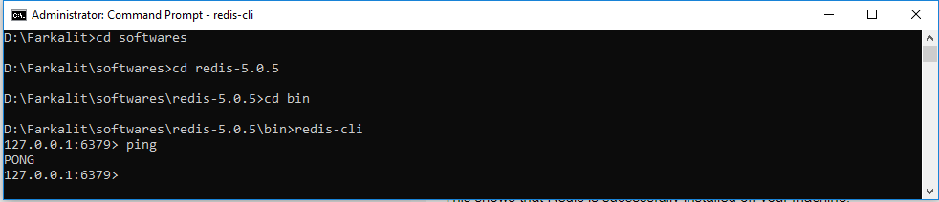

Some client commands: ping, echo, info, CONFIG get *, quit etc.

1. Run Commands on the Remote Server

**$ redis-cli -h host -p port -a password**

**BIN>** redis-server ../redis.conf

**BIN> redis-cli -h 10.7.91.40**

**On UAT**

**BIN> redis-cli -h 10.1.131.136**

## Set the Password

1. Need to configure the “requirepass” by using $redis-cli command.

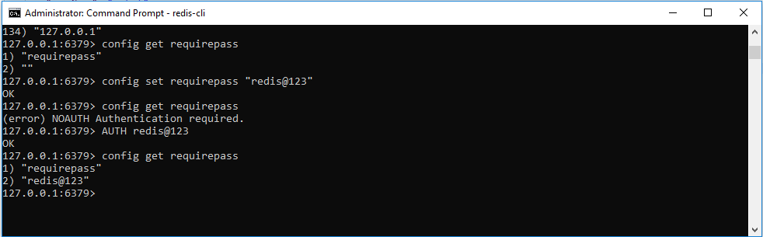

Or With host IP address & port number:

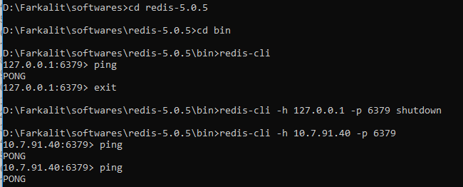

## Uses of Redis with Springboot

1. @Cacheable (cacheName=””, unless=””)//to store it
2. @CachePut()()//to store it and it is not checking if it exists
3. @CacheEvict ()//to delete from cache

## Redis on Linux

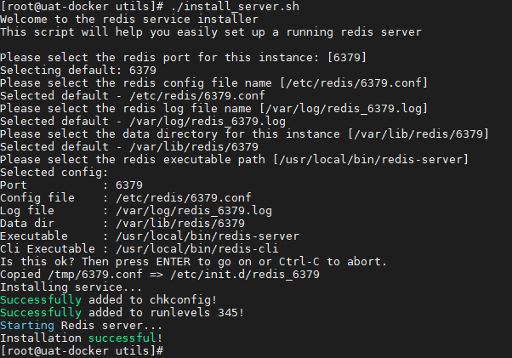

## Redis Client Command

Redis-cli –h 10.7.91.40

<List all the key available in the cache>

$ KEYS *

$ get accountCache::195842

$ scan 0

## For Further Reading

1. Redis-5.x: <https://www.tutorialspoint.com/redis/index.htm>
2. Spring docs: <https://docs.spring.io/spring-data/data-redis/docs/current/reference/html/#reference> (5.14.1. Support for the Spring Cache Abstraction)
3. With Spring boot: <https://www.devglan.com/spring-boot/spring-boot-redis-cache>
4. Good example: <https://www.journaldev.com/18141/spring-boot-redis-cache>
5. Why and how to use it:

<https://dzone.com/articles/implementation-of-redis-in-micro-servicespring-boo>